## **User Guide**

In this module (**Bluethinkinc_AddNewAddressField**)

First of all you need to goto Stores ->Configuration ->BLUETHINKINC ->Add Address Field

And Add multiple fields using click on **Add** button then click on **save config**.

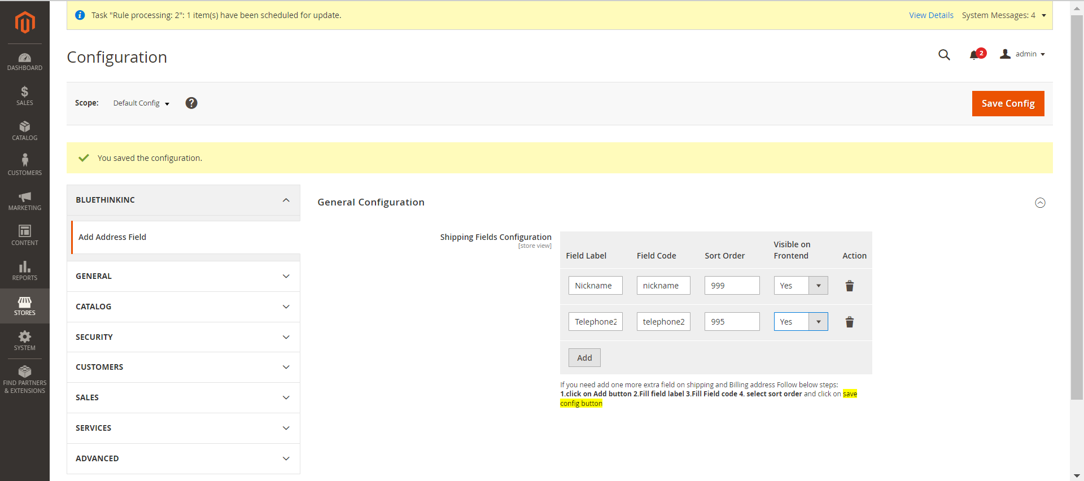

You can use **visible on Frontend** If you want to display field in address book then

Select **Yes** otherwise **No**

**2.**Then goto  **Stores ->Configuration ->Customers ->Customer Configuration ->Address Templates -> HTML**

And add all the fields which are added in **Stores ->Configuration ->BLUETHINKINC ->Add Address Field** path. Using this way

**{{depend field_code}}<br />Field Level: {{var field_code}}{{/depend}}**

Like as (

**{{depend nickname}}<br />Nickname: {{var nickname}}{{/depend}}<br/>**

**{{depend telephone2}}<br />Telephone2: {{var telephone2}}{{/depend}}**

)

Same as add in

**Stores ->Configuration ->Customers ->Customer Configuration ->Address Templates -> PDF**

And add all the fields which are added in **Stores ->Configuration ->BLUETHINKINC ->Add Address Field** path. Using this way

**{{depend field_code}}<br />Field Level: {{var field_code}}{{/depend}}**

Like as (

**{{depend nickname}}<br />Nickname: {{var nickname}}{{/depend}}<br/>**

**{{depend telephone2}}<br />Telephone2: {{var telephone2}}{{/depend}}**

)

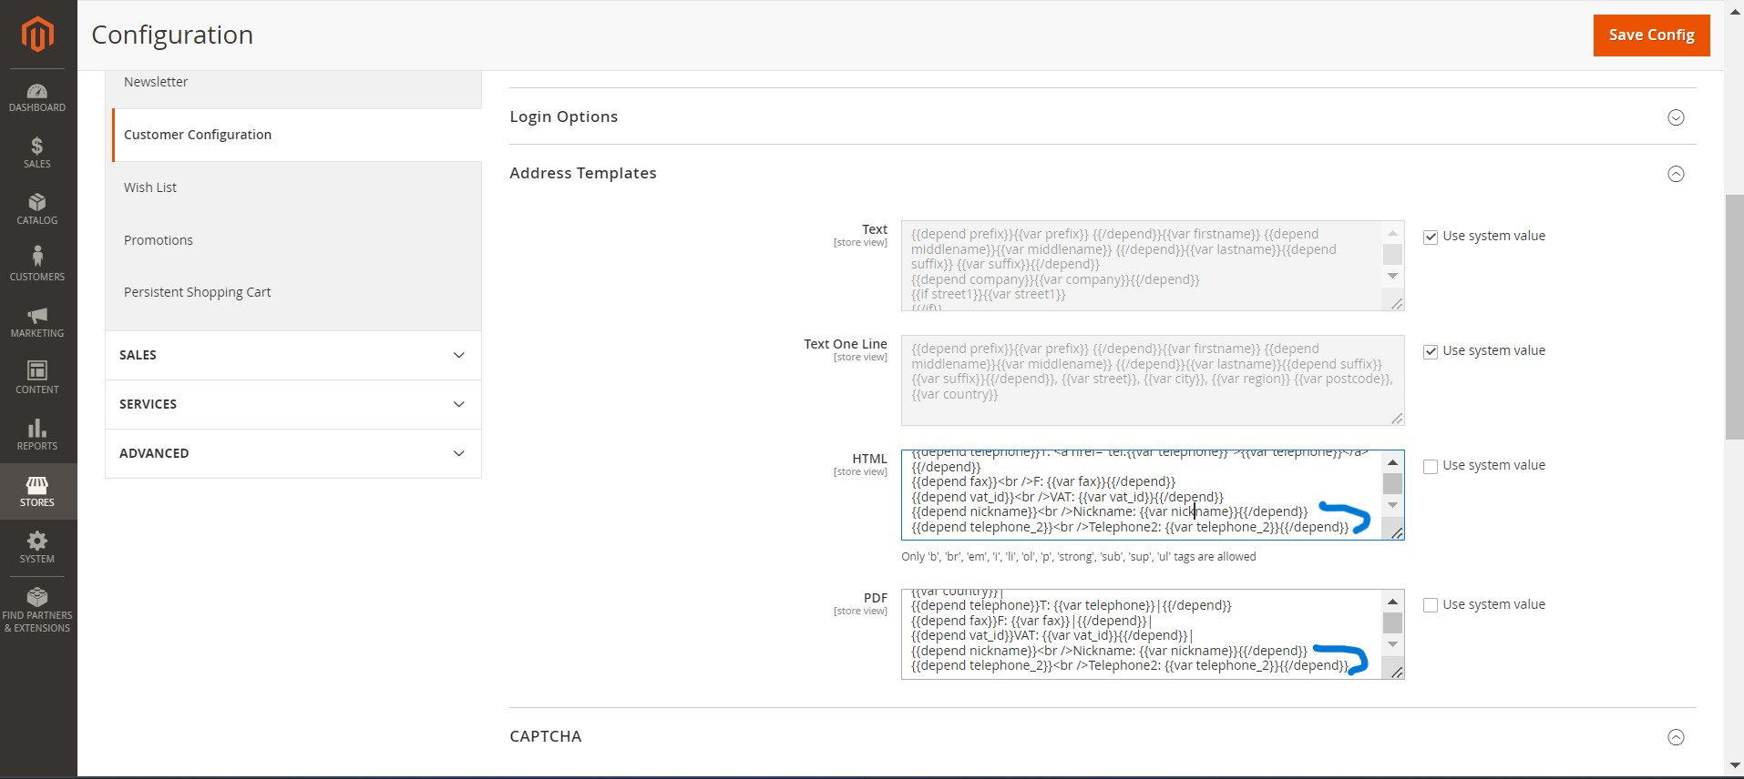

**3.** Then goto **frontend** and **sign In customer** then click on anyone product and click on **Add to cart** button then goto cart and click on **Proceed to Checkout**

Then you can see your custom field which is create in **admin panel** with **visible on frontend** property

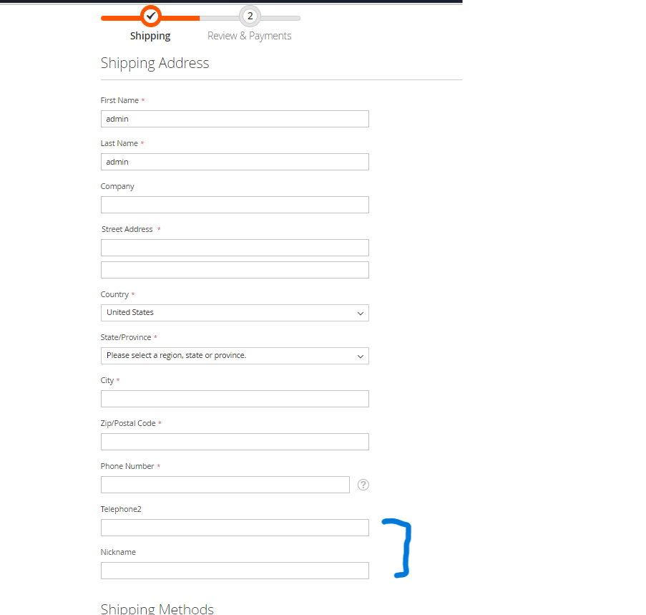

Then select payment-method and click on **next** button then select

**checkbox (My billing and shipping address are the same)**

Then place an order .

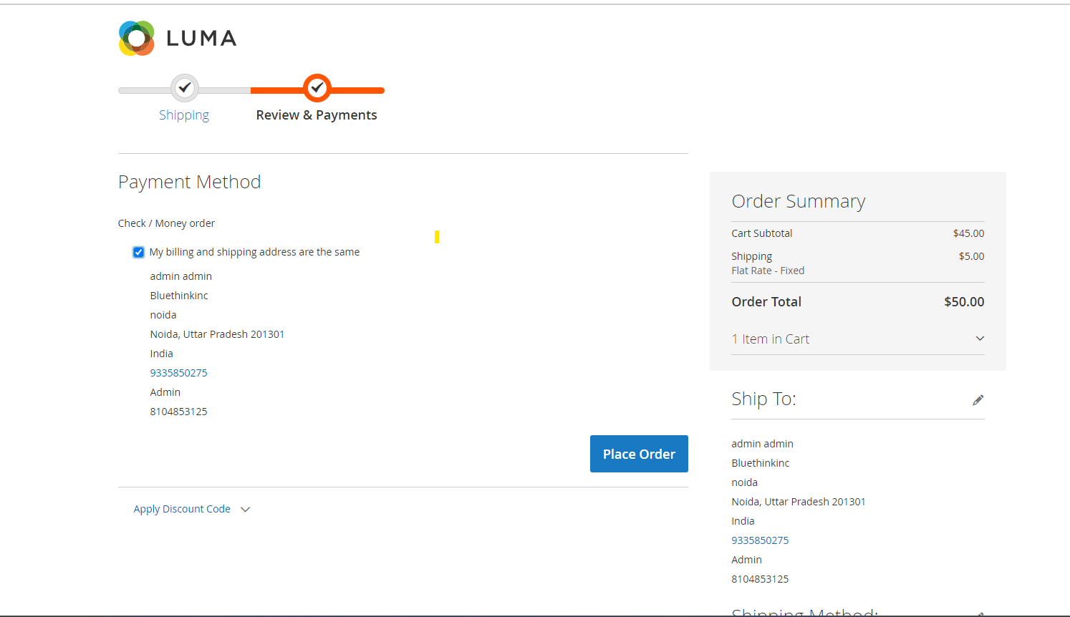

After place order you can see your custom field which is created using admin panel

You can see the locations below.

1. Click on my account button then click on click on My Orders then view

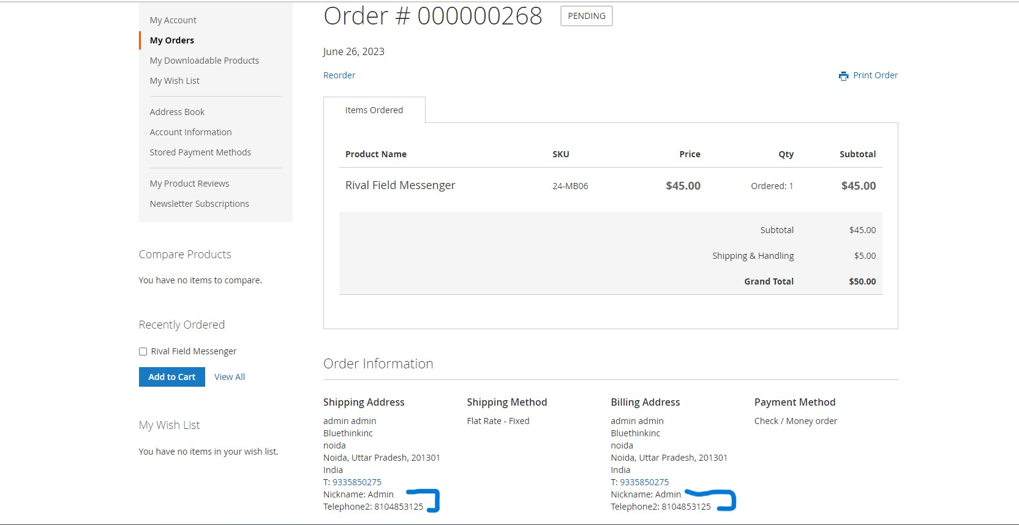

1. Click on my account button then click on click on Address Book

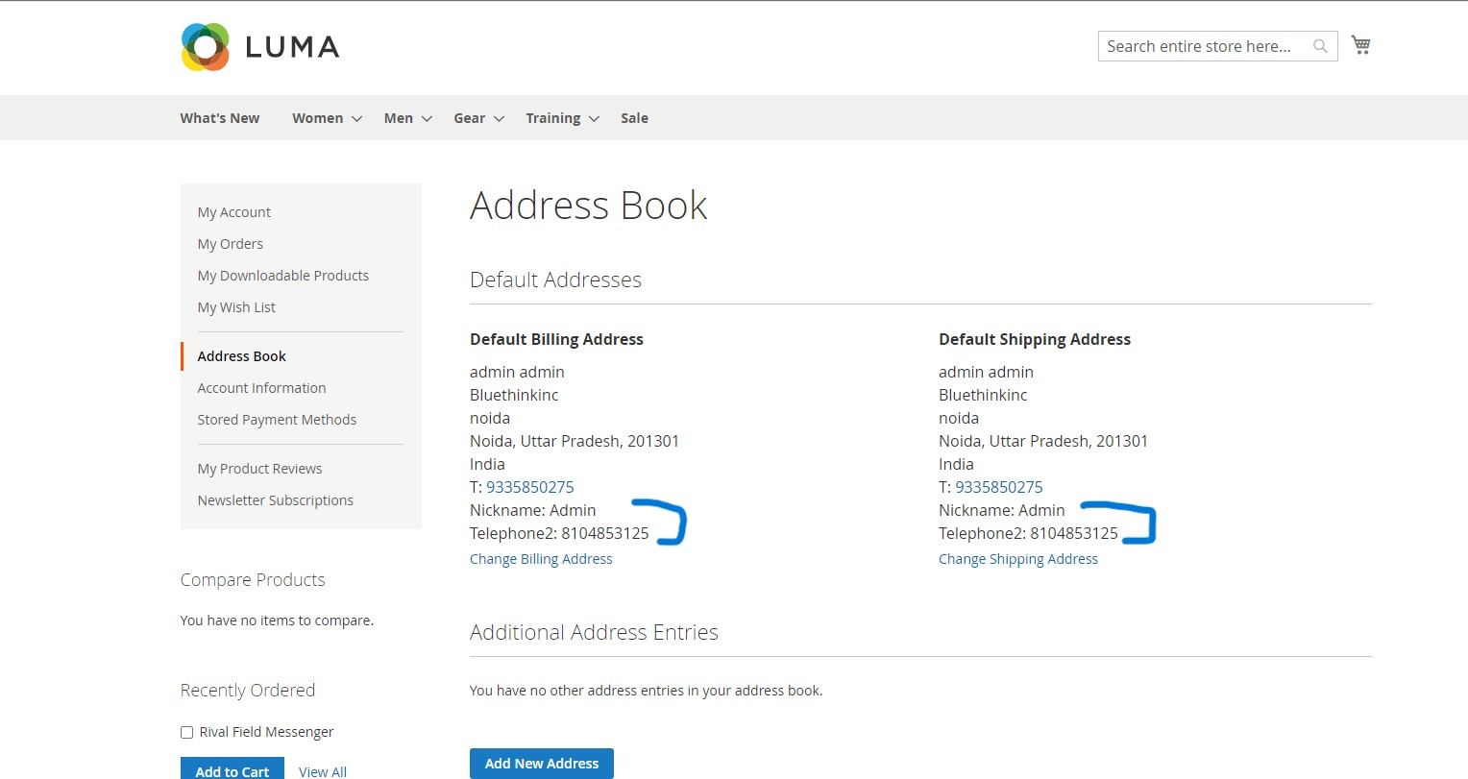

1. In admin panel goto sales ->Orders

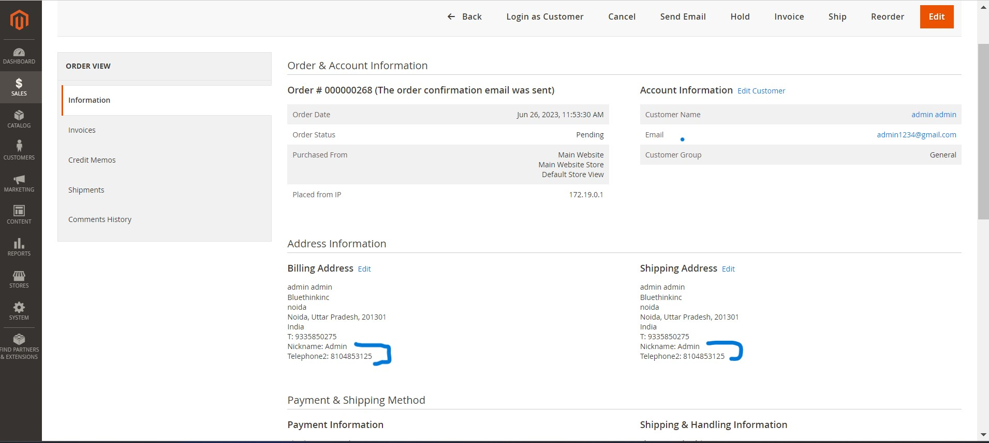

Then generate Invoice then view invoice

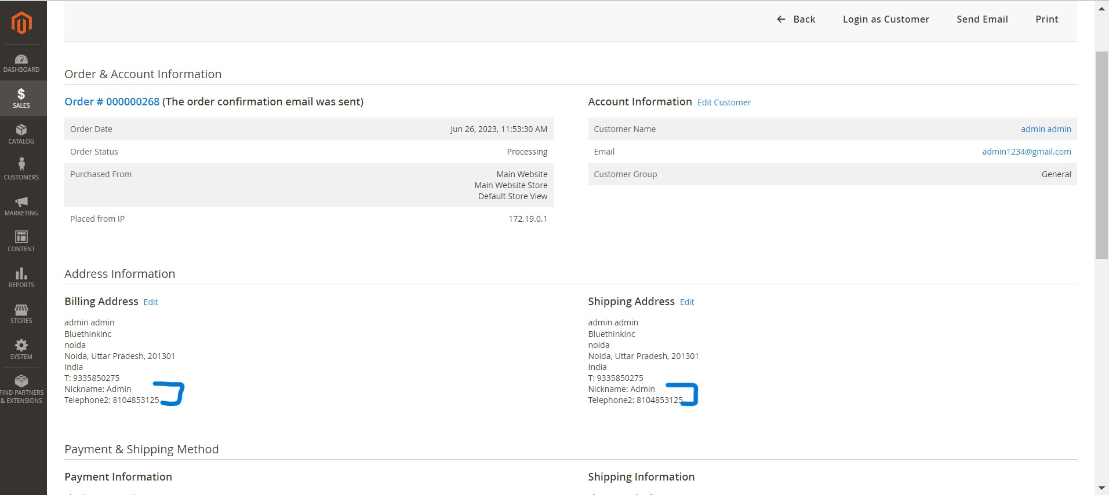

And print invoice

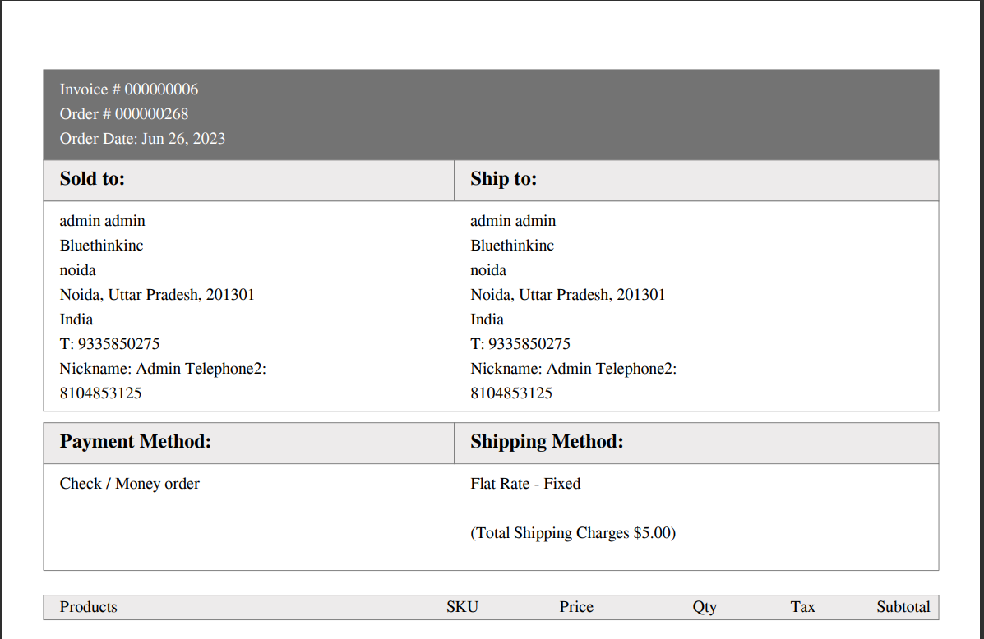

And when click on send Email

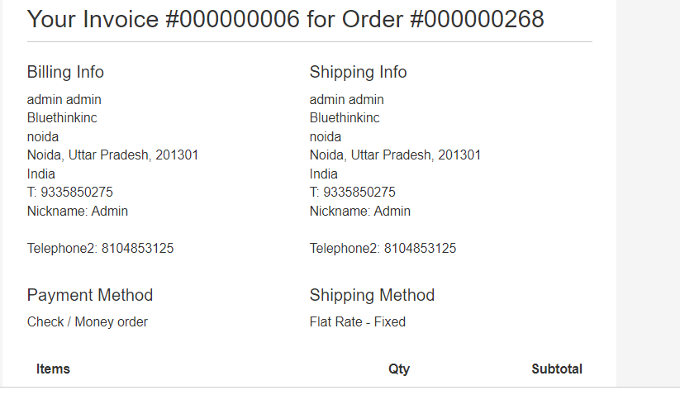

1. In admin panel after order shipped then goto sales ->Shipment

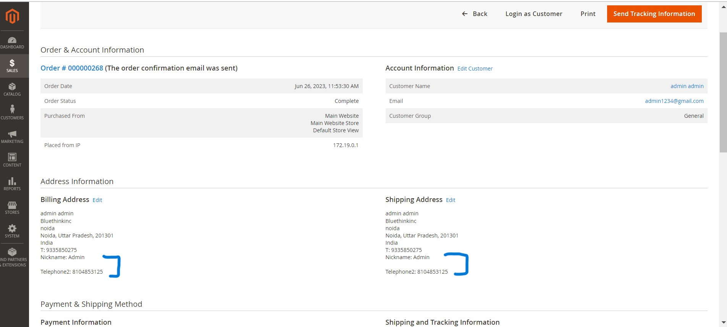

And when print then

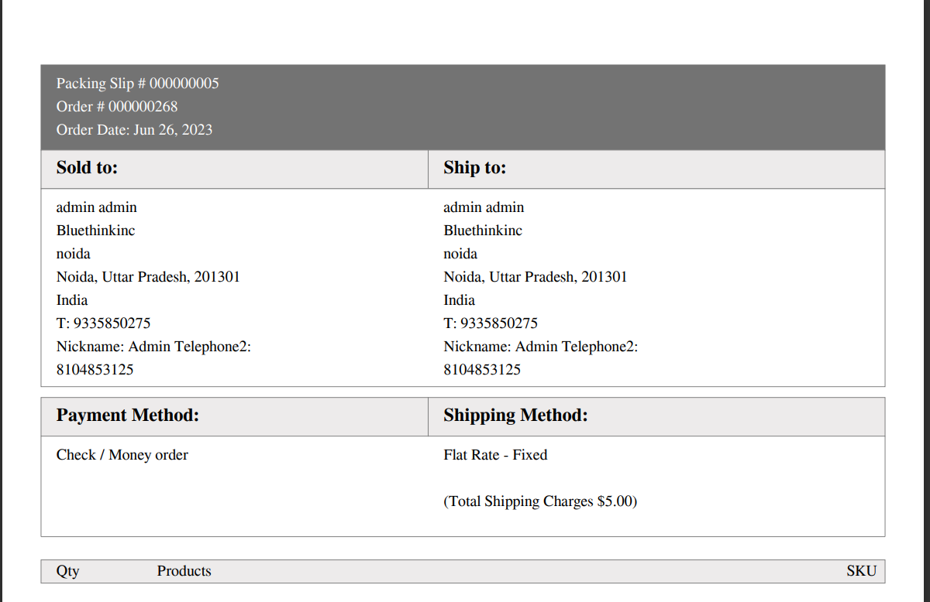

1. When create credit memo

Goto sales ->Credit Memos

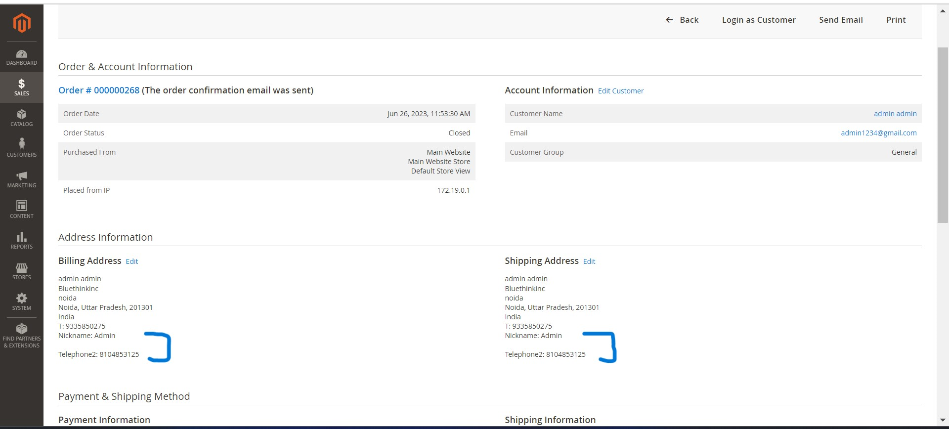

And when print then

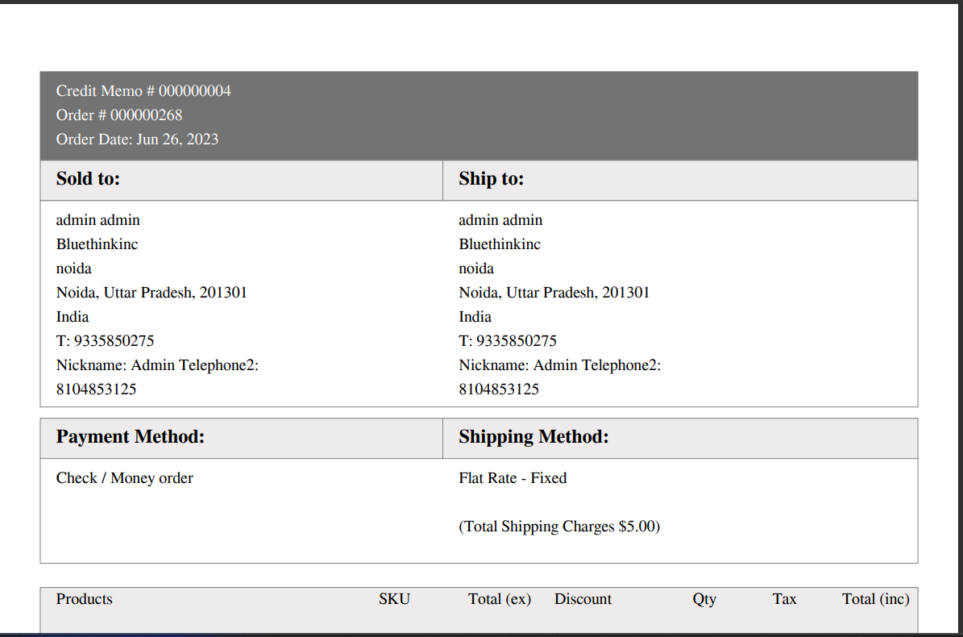

And when send Email

